CSC1001 Assignment 3

#顺带一提由于我很晚才发现我的test中result的序号有问题，固不改了，统一对应\n Question序号（能完成相同任务的情况下最好的程序不就是最懒的那个吗）

Question 1:

1. This code is saved in q1.py
2. This code will initialize a flower including its name, petals and price. This code allows users to input new names/petals/price and will deal with the incorrect input. (Name must be string, otherwise it (the code) will tell the input is incorrect. Petals will be changed into integer if the input is ‘4.0’ but will tell the input is incorrect if the input is ‘4.3’ or other types. Price will be accurate to two decimal places and it will tell the input is incorrect.
3. Executes as follows:

Test 1

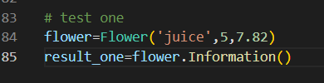



Test 2

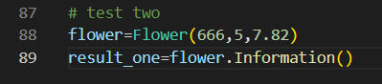



Test 3

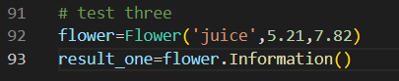



Question 2:

1. This code is saved in q2.py
2. This code will give the first-derivative of the input polynomial.
3. Executes as follows:

Test 1

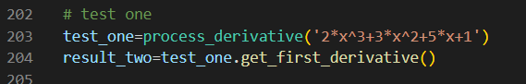

Test 2

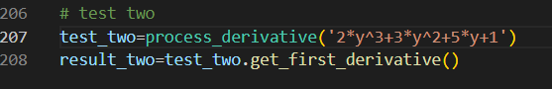

(往下懒得一遍遍弄格式了为了清晰只不裁全文件名)

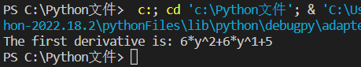

Test 3

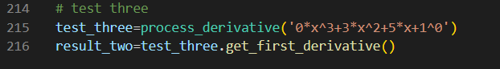

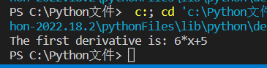

Test 4

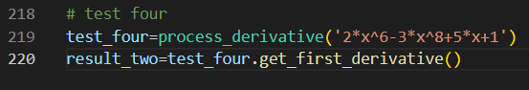

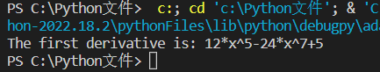

Test 5

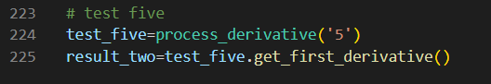

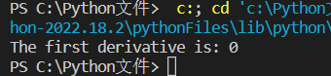

Question 3:

1. This code is saved in q3.py
2. This code will simulate an ecosystem many times and allows the user to input the number of bears and fishes and the number of simulations.
3. Executes as follows:

Test 1

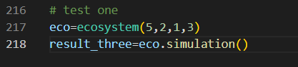

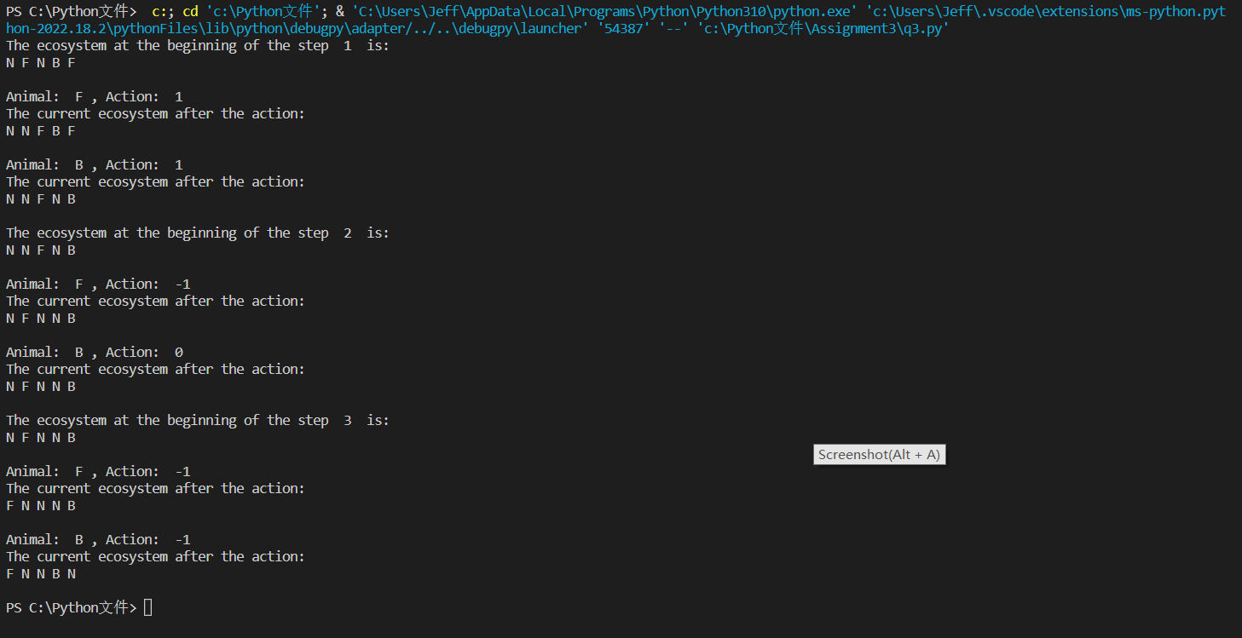

Test 2

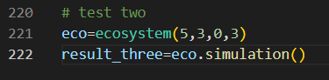

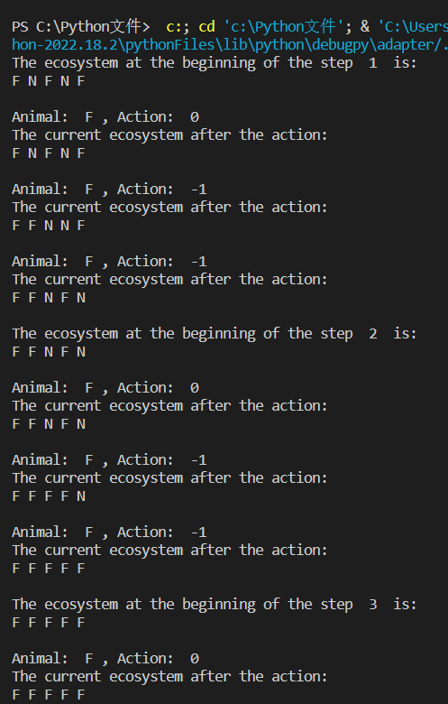

#下面这张图从step3开始，和上图最后两个结果重合（截图问题）

#图太大了摆下一页去了

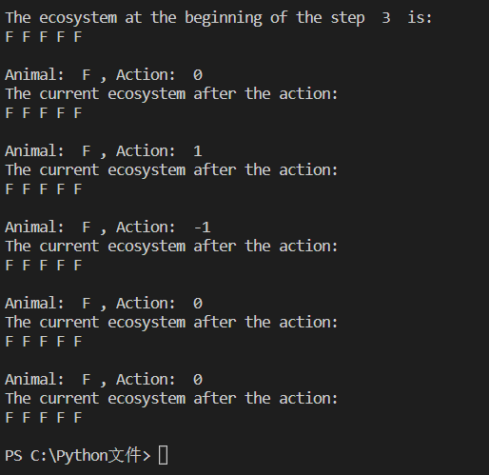

Test 3

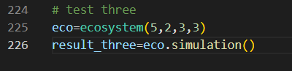

#图太大了在下一页

#可能是print有点多的原因文件地址没打全（下图蓝字第一行，这东西不是我能管的，跟\n我无关，可能只是偶然事件，请不要给我扣分谢谢）

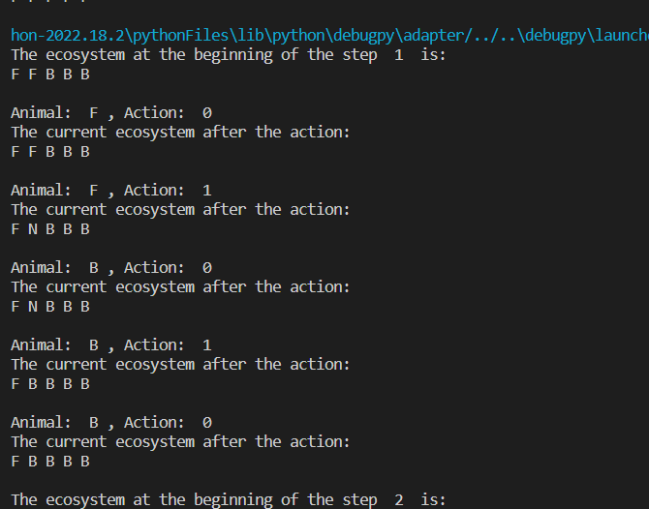

#重合一行让你知道结果是连续的

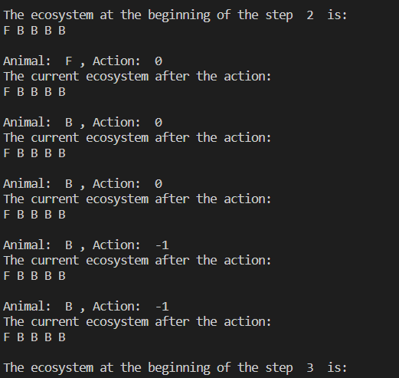

#图在下一页

